

SVKM’s NMIMS

Mukesh Patel School of Technology Management & Engineering

**THE MINISHOP SHOE STORE**

**Faculty mentor: Submitted By:**

MR.SURAJ PATIL MUSKAN CHOPRA:B269

SHIVAM GOLANI:B252

DEVANSH JAIN:B239

(Assistant Professor) Course: BTECH CE

MPSTME, NMIMS Academic Year:-2021-22

Shirpur Campus

|  |  |  |
| --- | --- | --- |
| Sr NO | Table Contents | Page No |
|  | Introduction | 3 |
|  | Architecture Framework | 4 |
|  | Front end designing | 5 |
|  | Backend Designing | 12 |
|  | Implementation Code | 14 |
|  | Results | 20 |
|  | References | 20 |

**INTRODUCTION**

Minisihop is a Shoestore Website i.e that allows the user to browse variety of shoes,choose n add to cart,n purchase the item.The Shoes are being displayed to the customer from a set of database being created on MySql,Thus applying knowledge of NODEJS WITH MY SQL The process consist of the shoe selection by the customer followed up by adding selected items to cart and also allowing the user to remove the product from cart if in future while buying he/she wishes to withdraw up their mind.Then it calculates the total cost of the shoes choosen n takes the customer to checkout page n then the payment page where payment gateway is integrated using paypal.

The whole Project is based on NodeJS,MySql,HTML,CSS,JS,Angular JS and is made using the best of the skills learned during the semester



**ARCHITECTURE FRAMEWORK**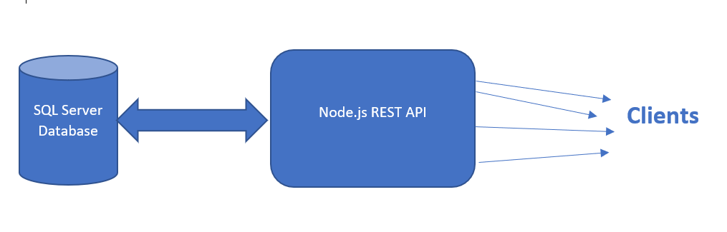

This architecture represents the technologies used in MiniShop ShoeStore

**Technologies Used in Detail:**

1. **Front End Technologies:**
2. HTML: HTML (HyperText Markup Language) is the code that is used to structure a web page and its content. For example, content could be structured within a set of paragraphs, a list of bulleted points, or using images and data tables.
3. JAVASCRIPT: JavaScript is a text-based programming language used both on the client-side and server-side that allows you to make web pages interactive. Where HTML and CSS are languages that give structure and style to web pages, JavaScript gives web pages interactive elements that engage a user.
4. BOOTSTRAP: Bootstrap CSS is basically a utility-first CSS framework forrapidly building custom user interfaces. It is customizable CSS framework that gives you all of the building blocks you need to build a website

4.React Libraries:

PayPal ( to add the payment Gateway)

**II.Back-end / server side application:**

1. **NodeJS:** NodeJS is an open source development platform for executing JavaScript code server-side. Node is useful for developing applications that require a persistentconnection from the browser to the server and is often used for real-time applications.
2. **ExpressJS :** ExpressJS is a free and open-source web application framework for NodeJS. It is used fordesigning and building web applications quickly and easily.
3. **MySQL:** MySQL is a tool used to manage databases and servers, so while it's not a database, it's widely used in relation to managing and organising data in databases.

**FRONT-END DESIGNING:**

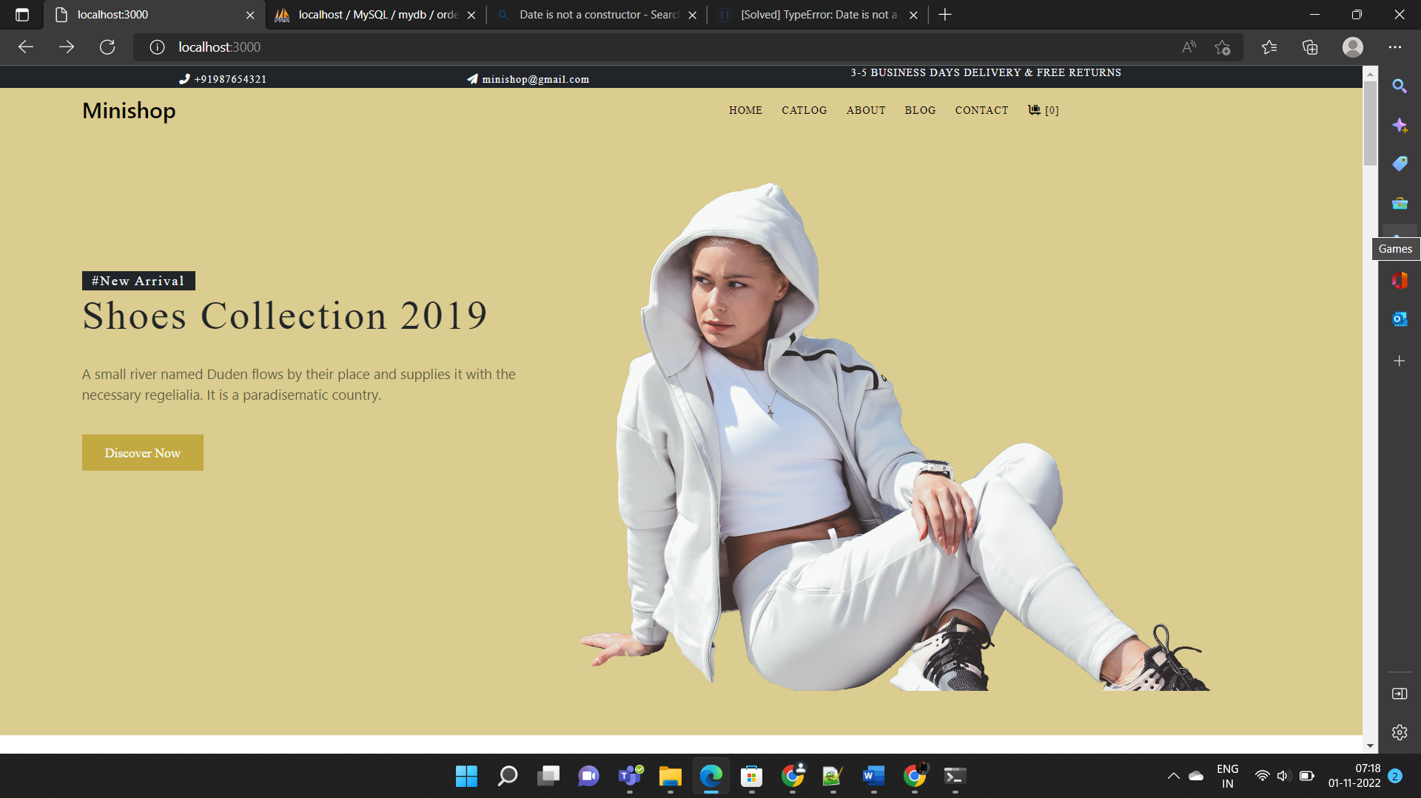

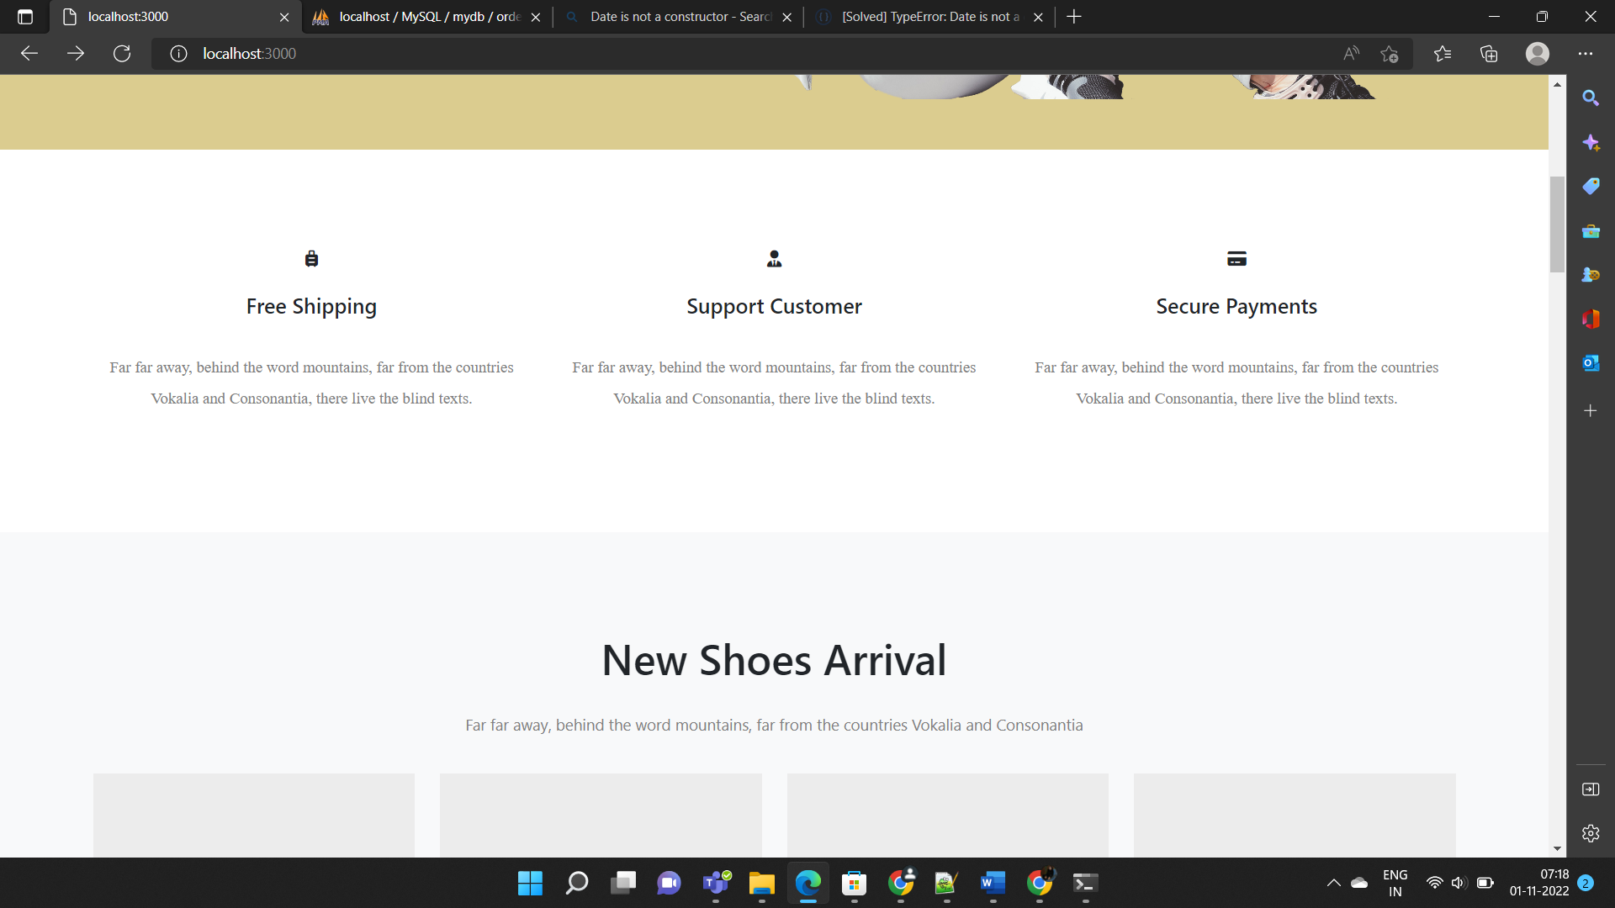

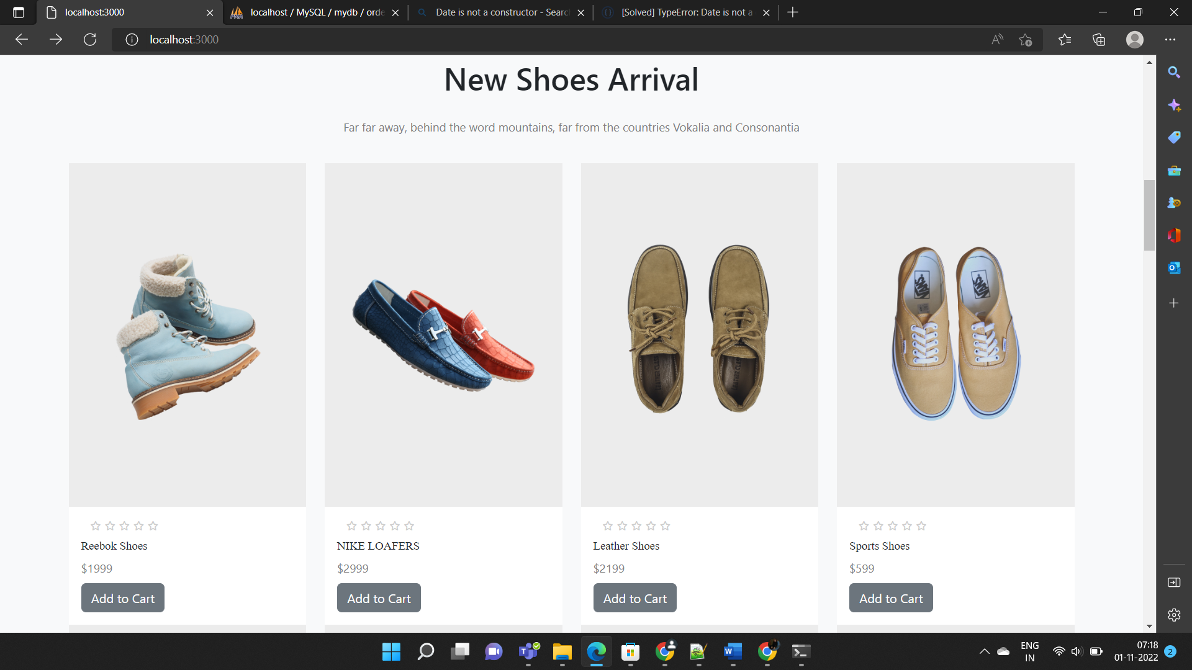

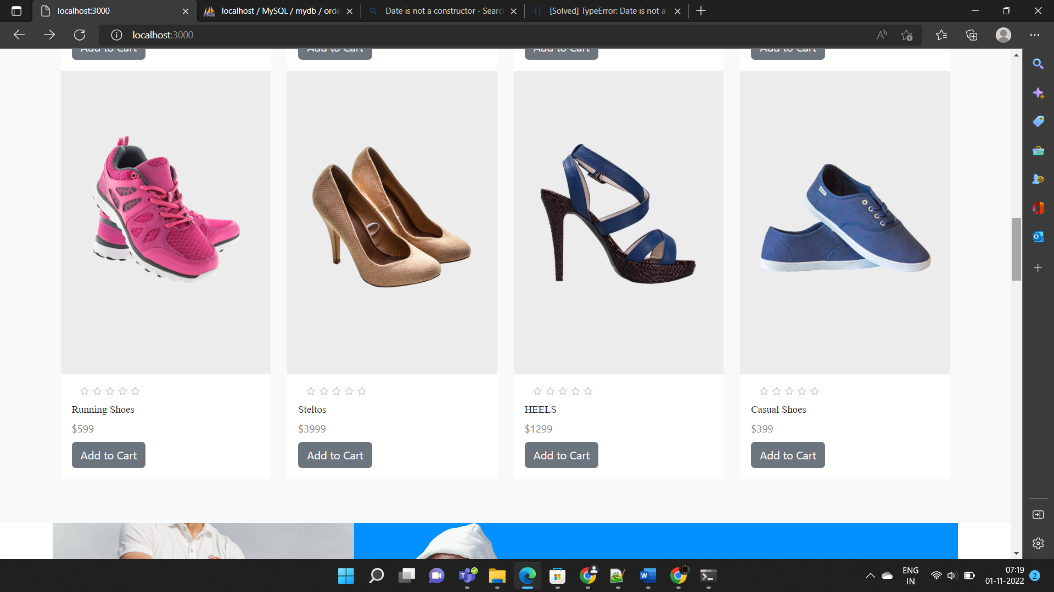

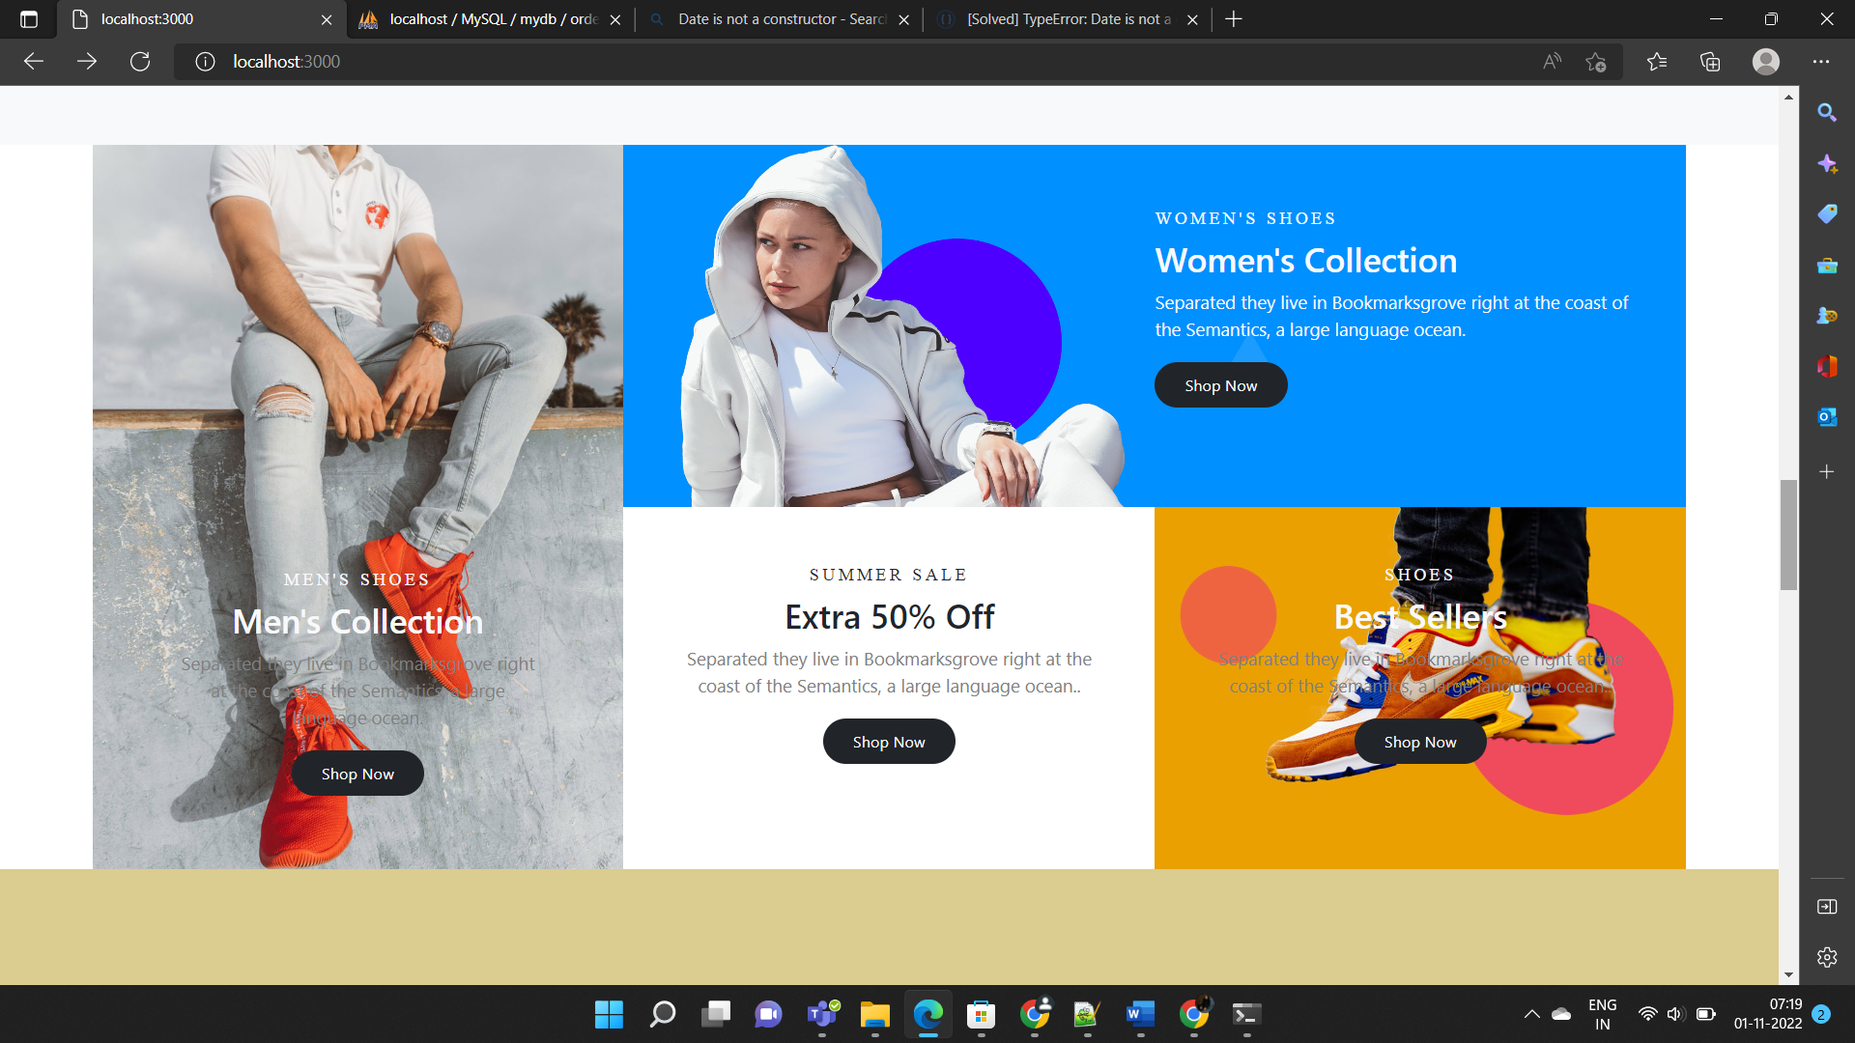

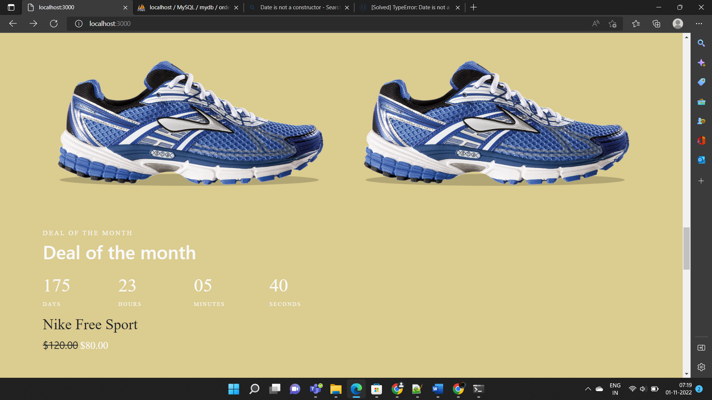

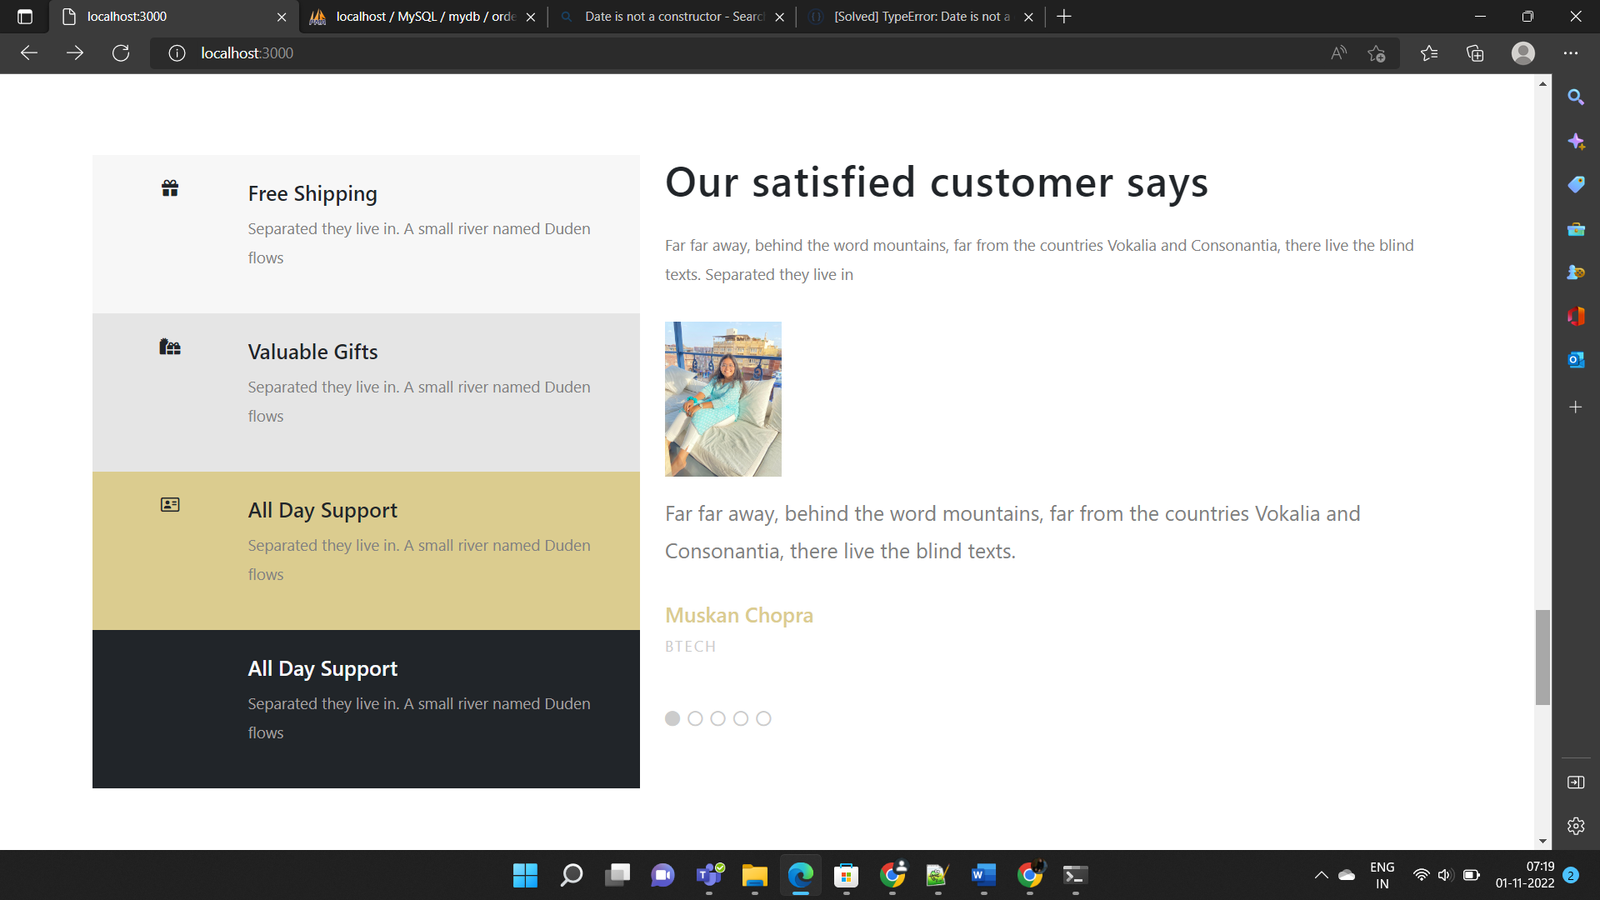

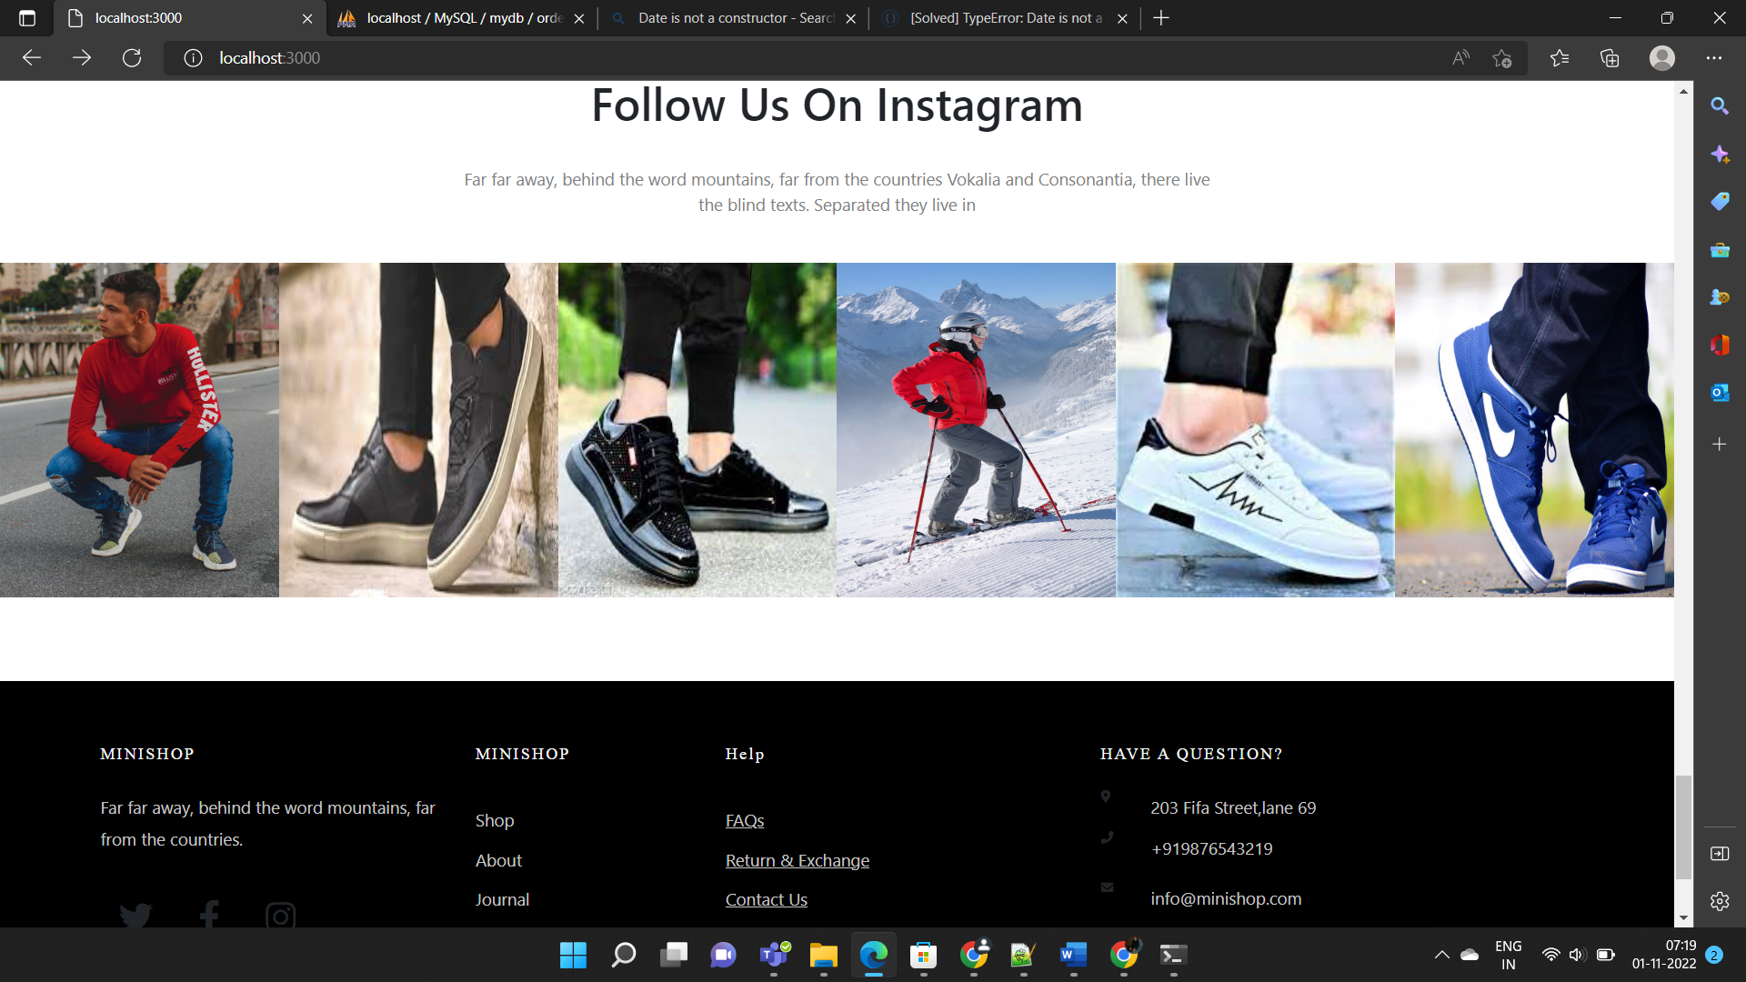

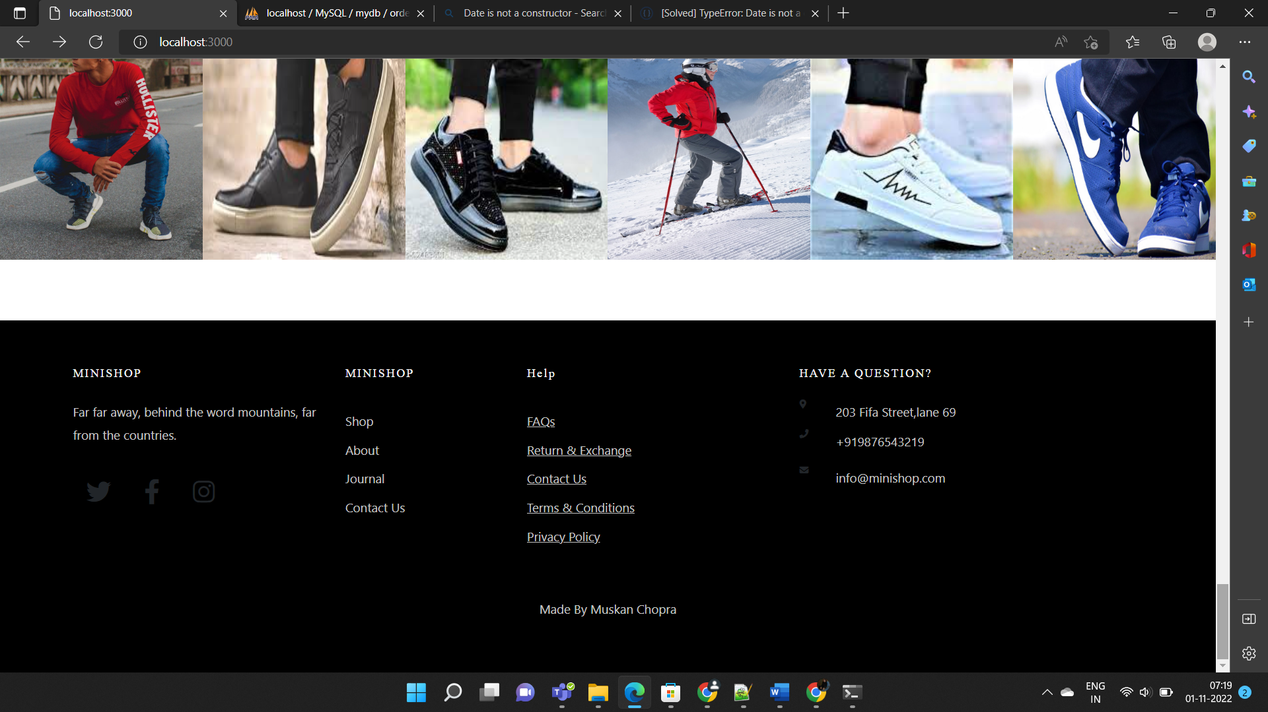

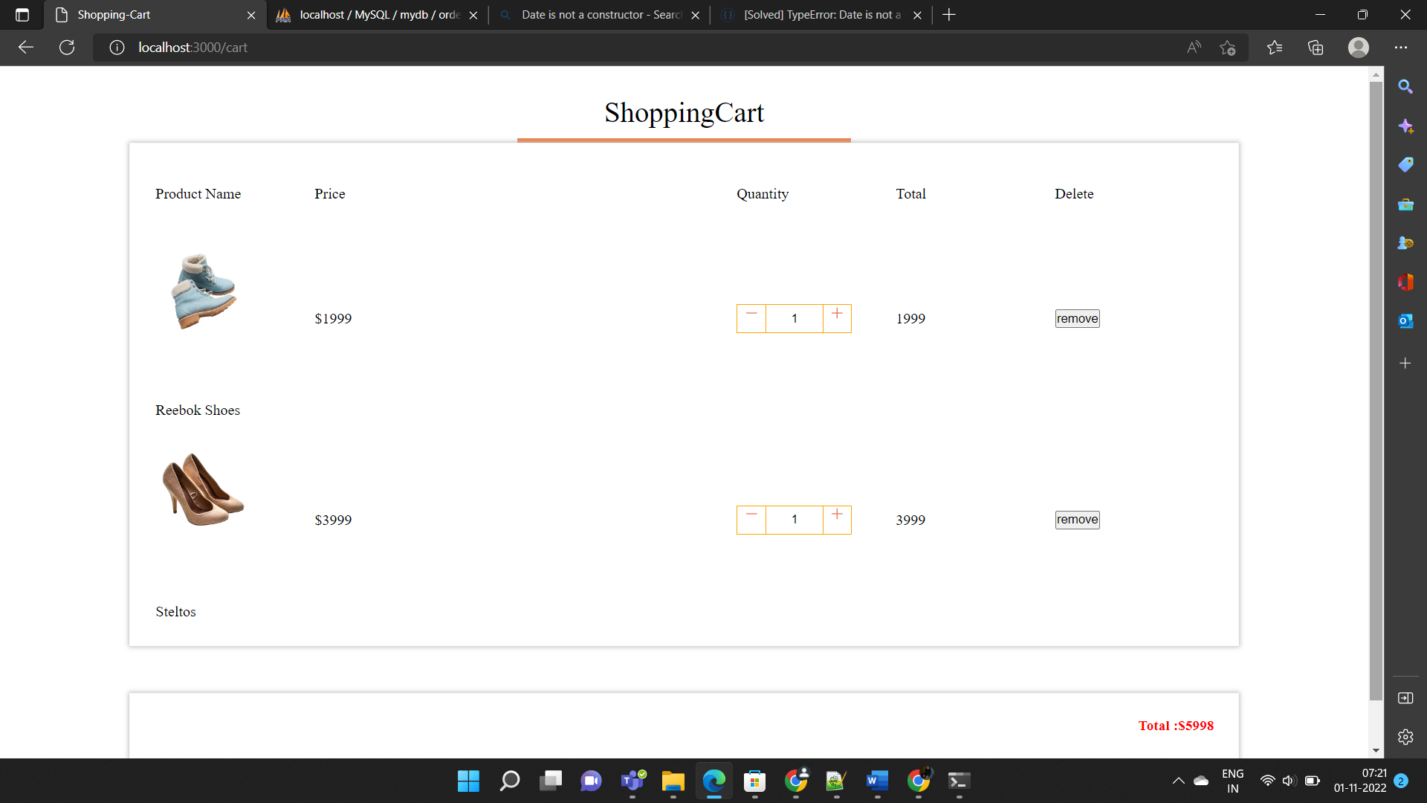

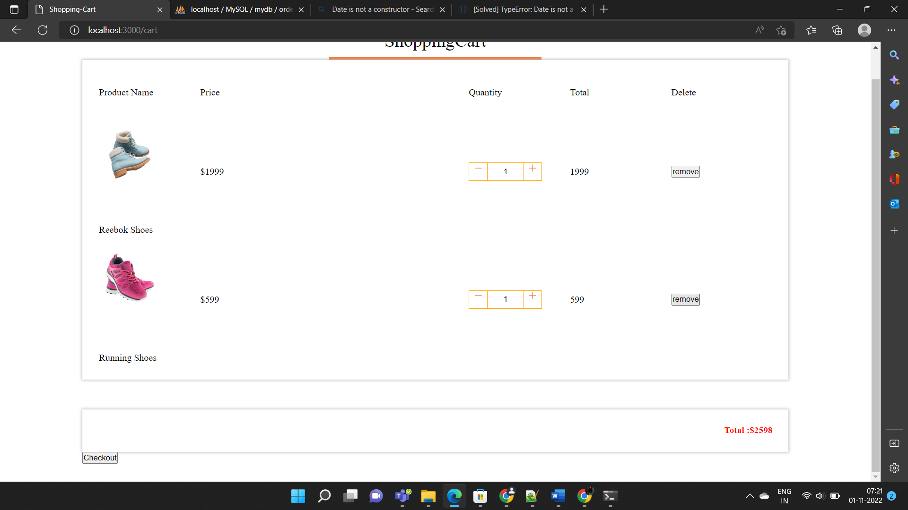

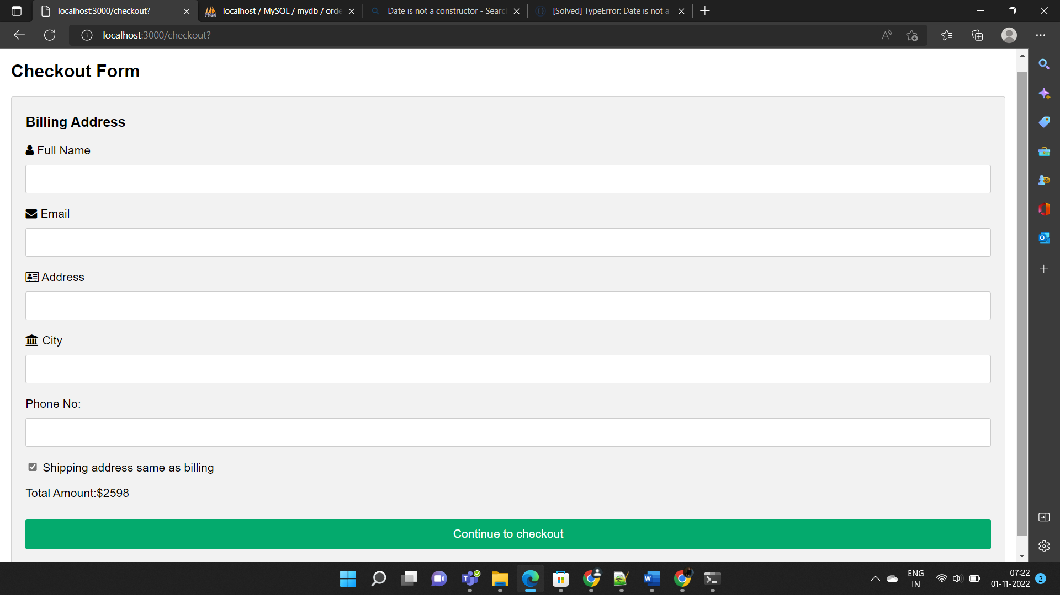

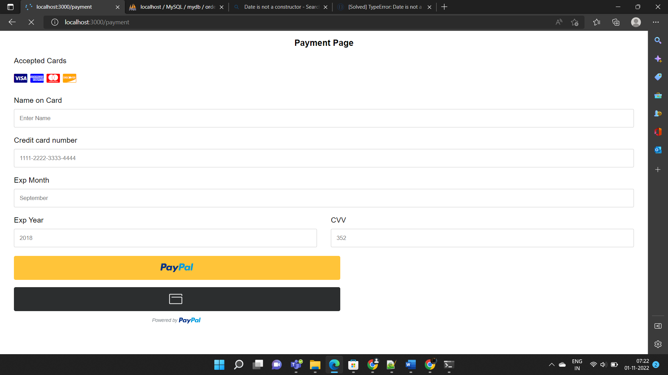

**BACKEND-DESIGN/DATA**

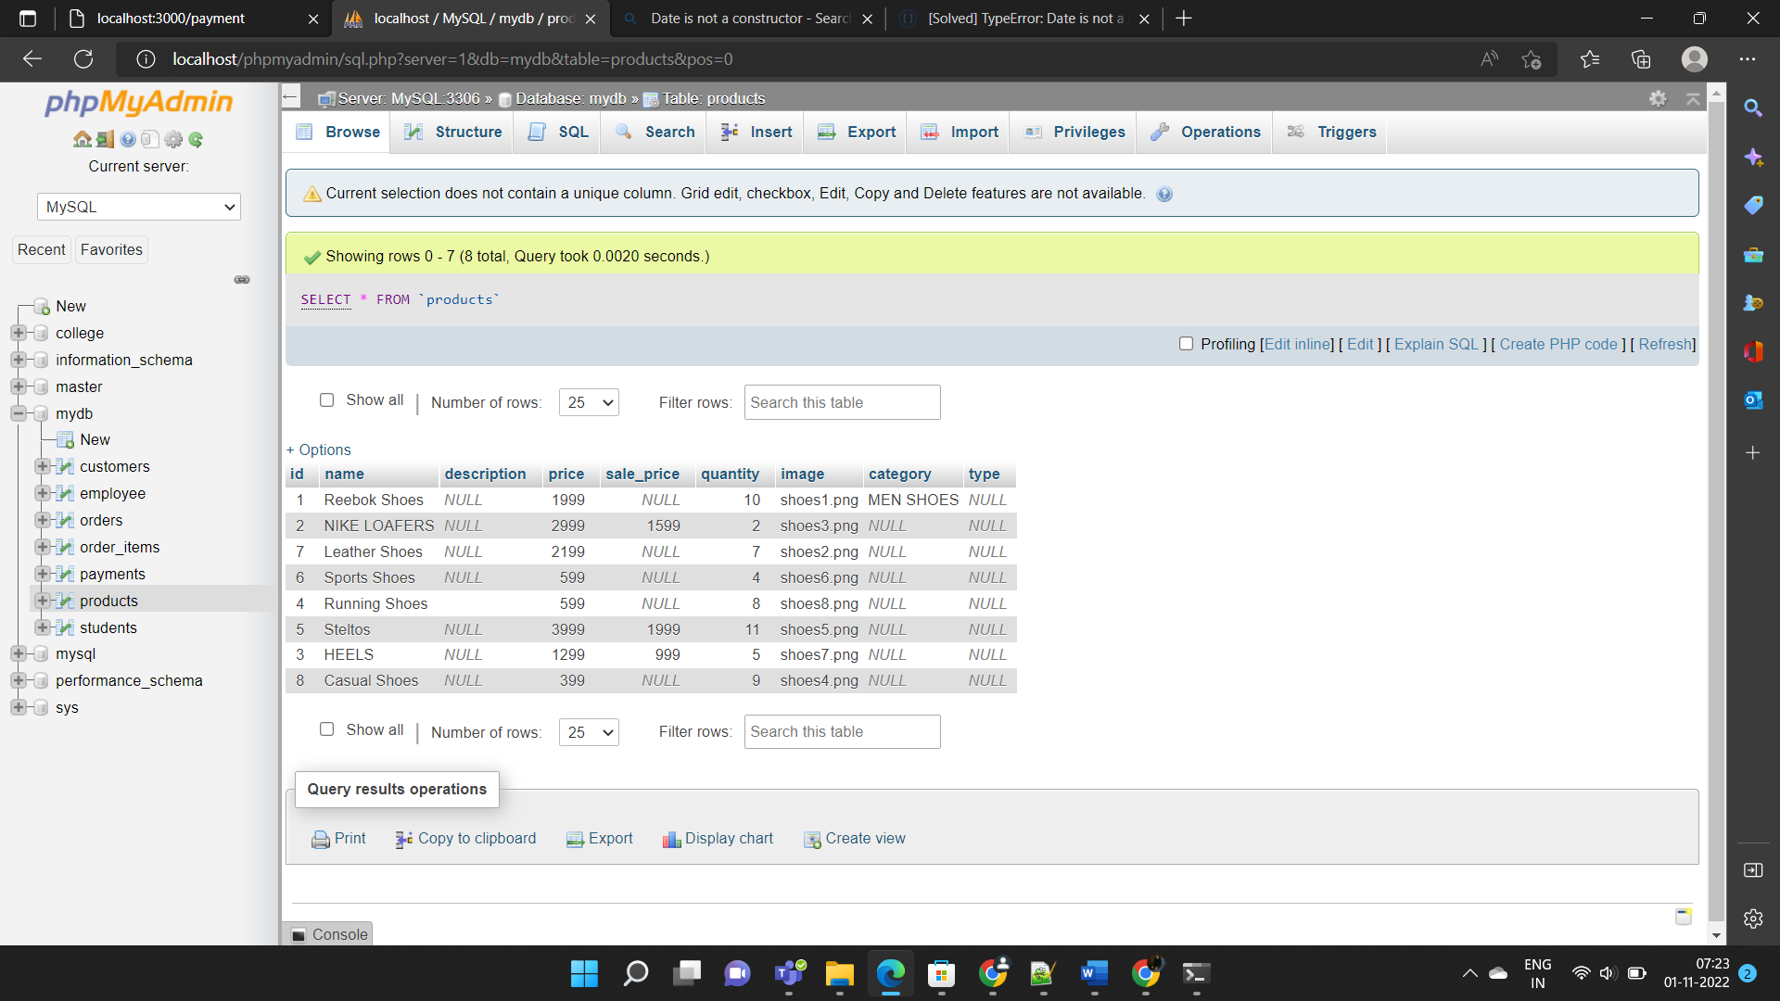

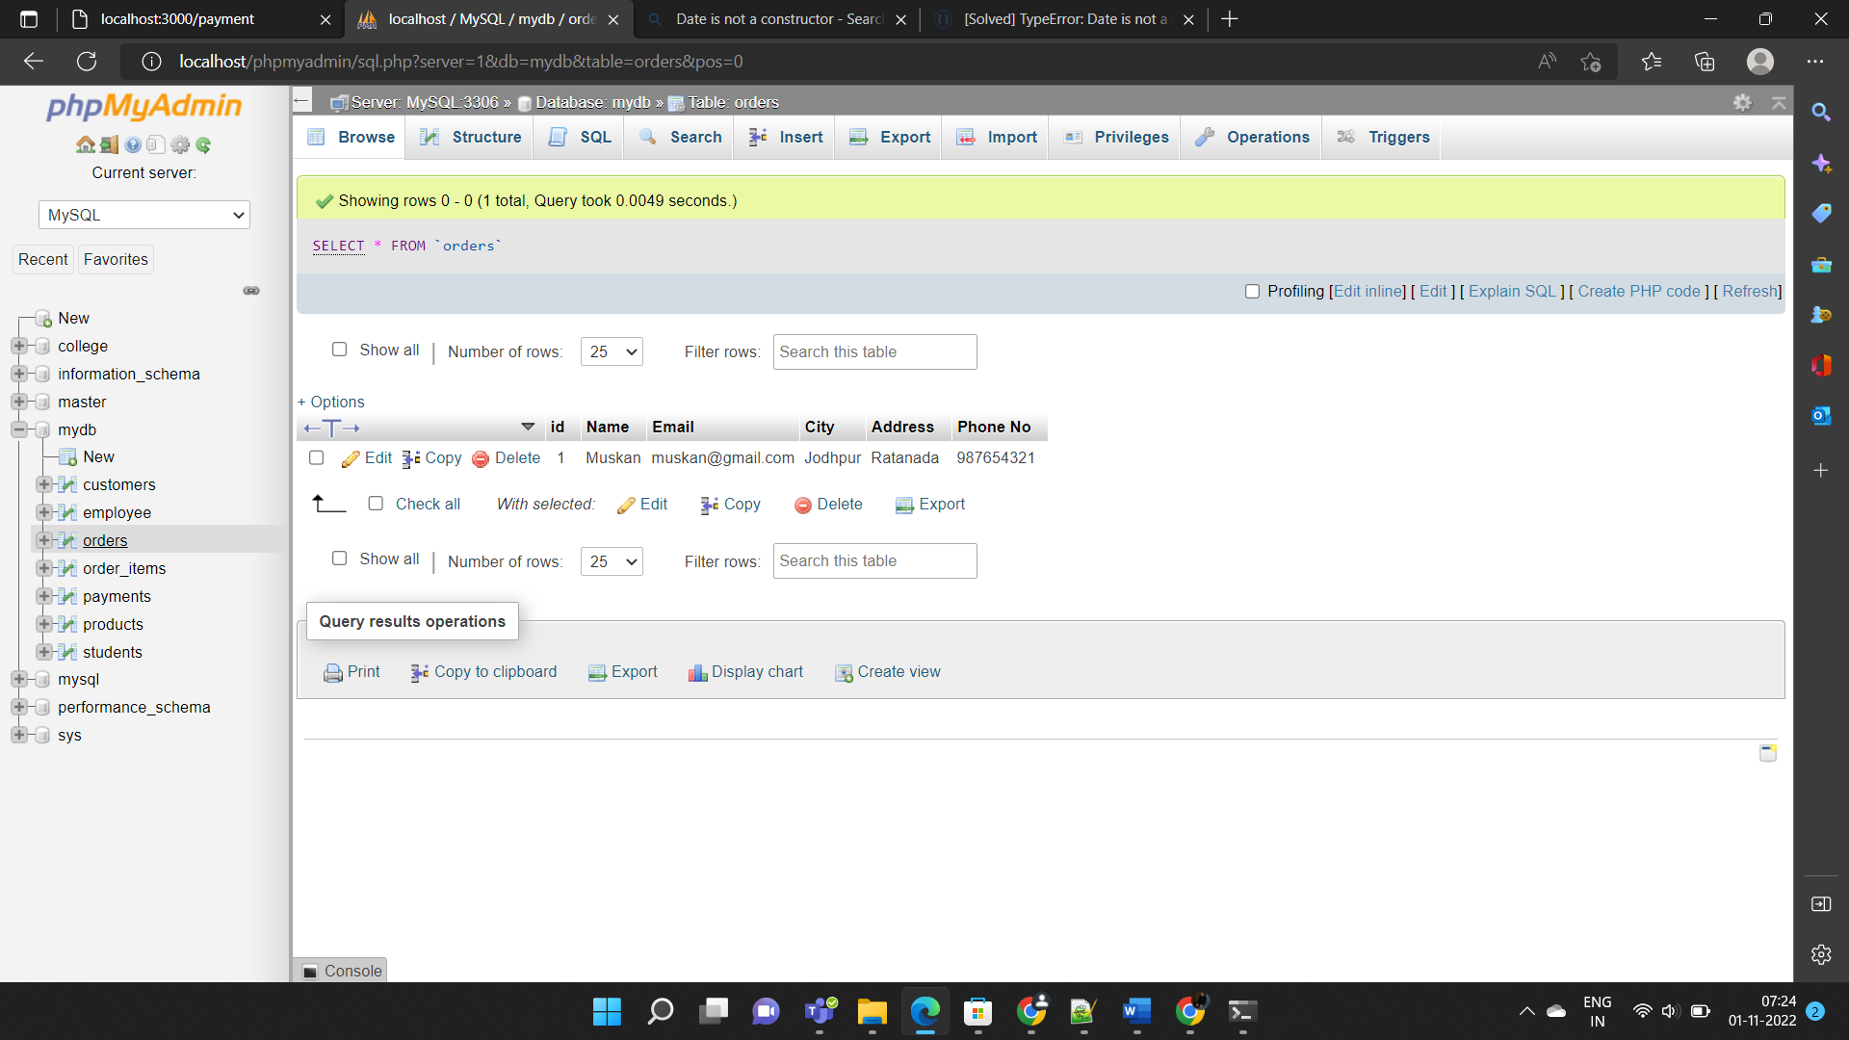

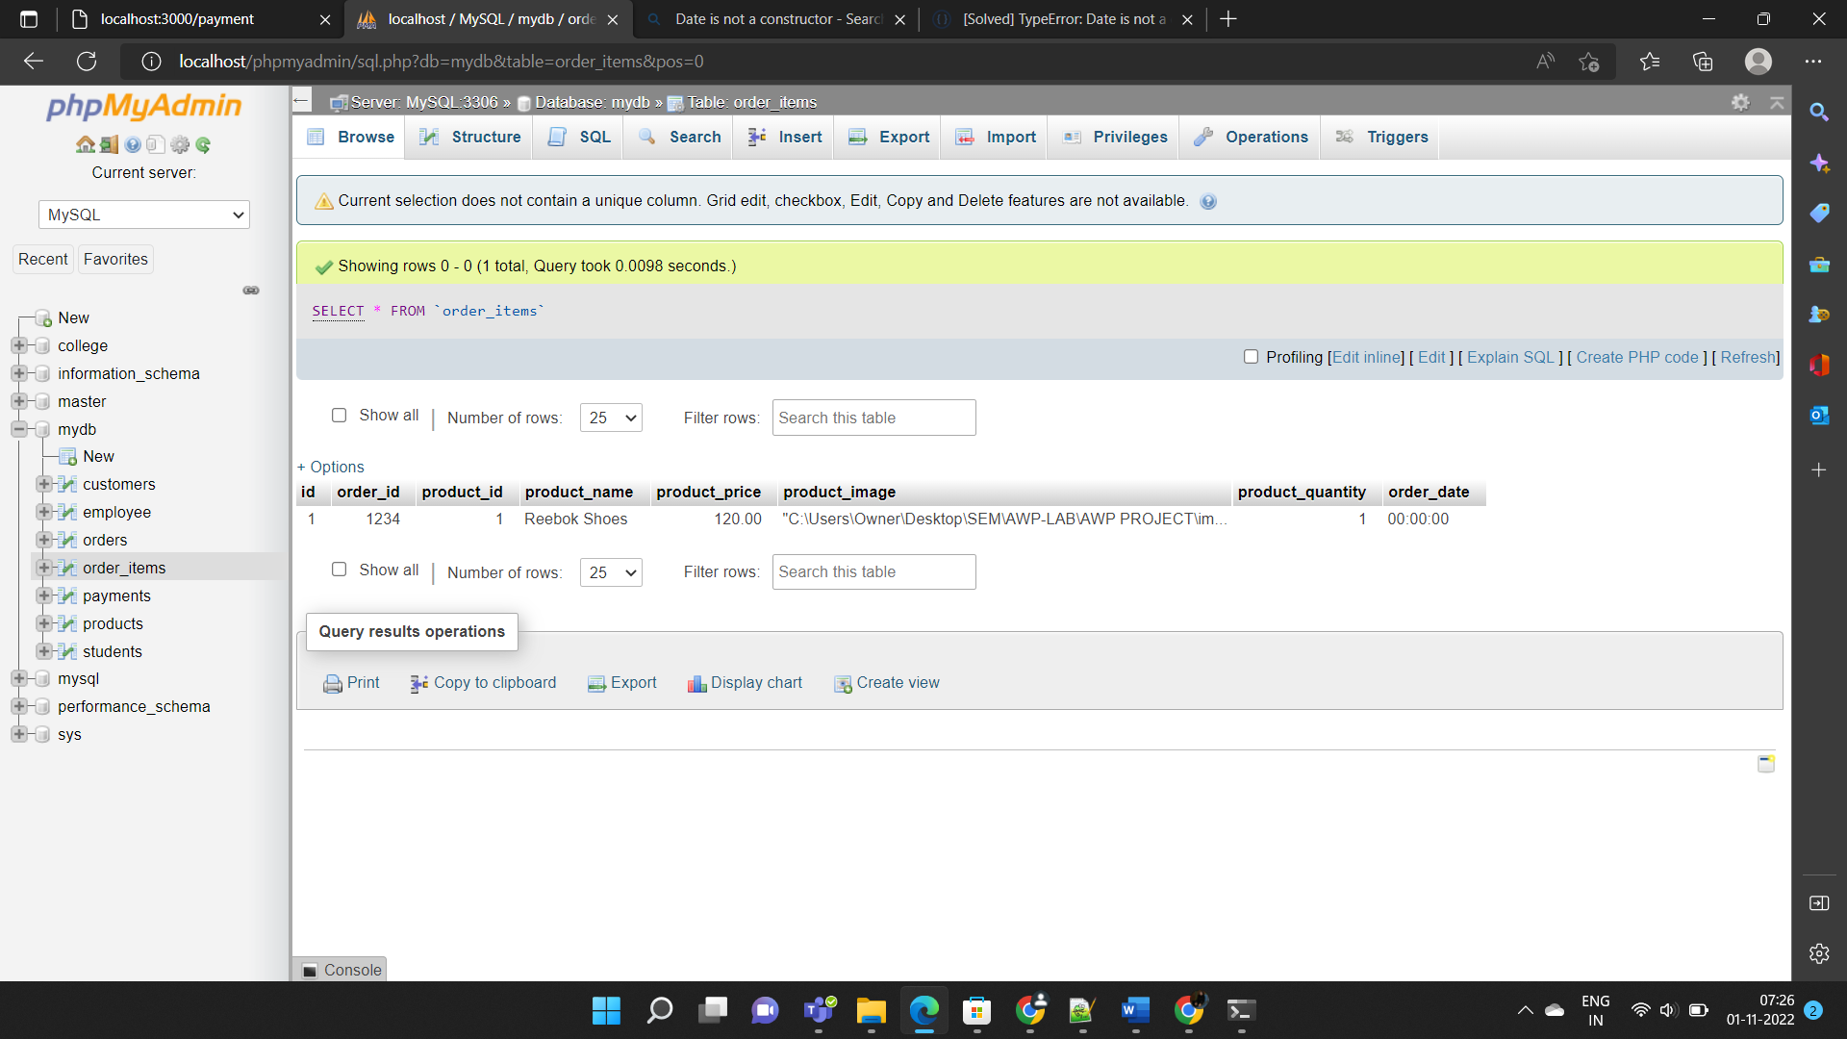

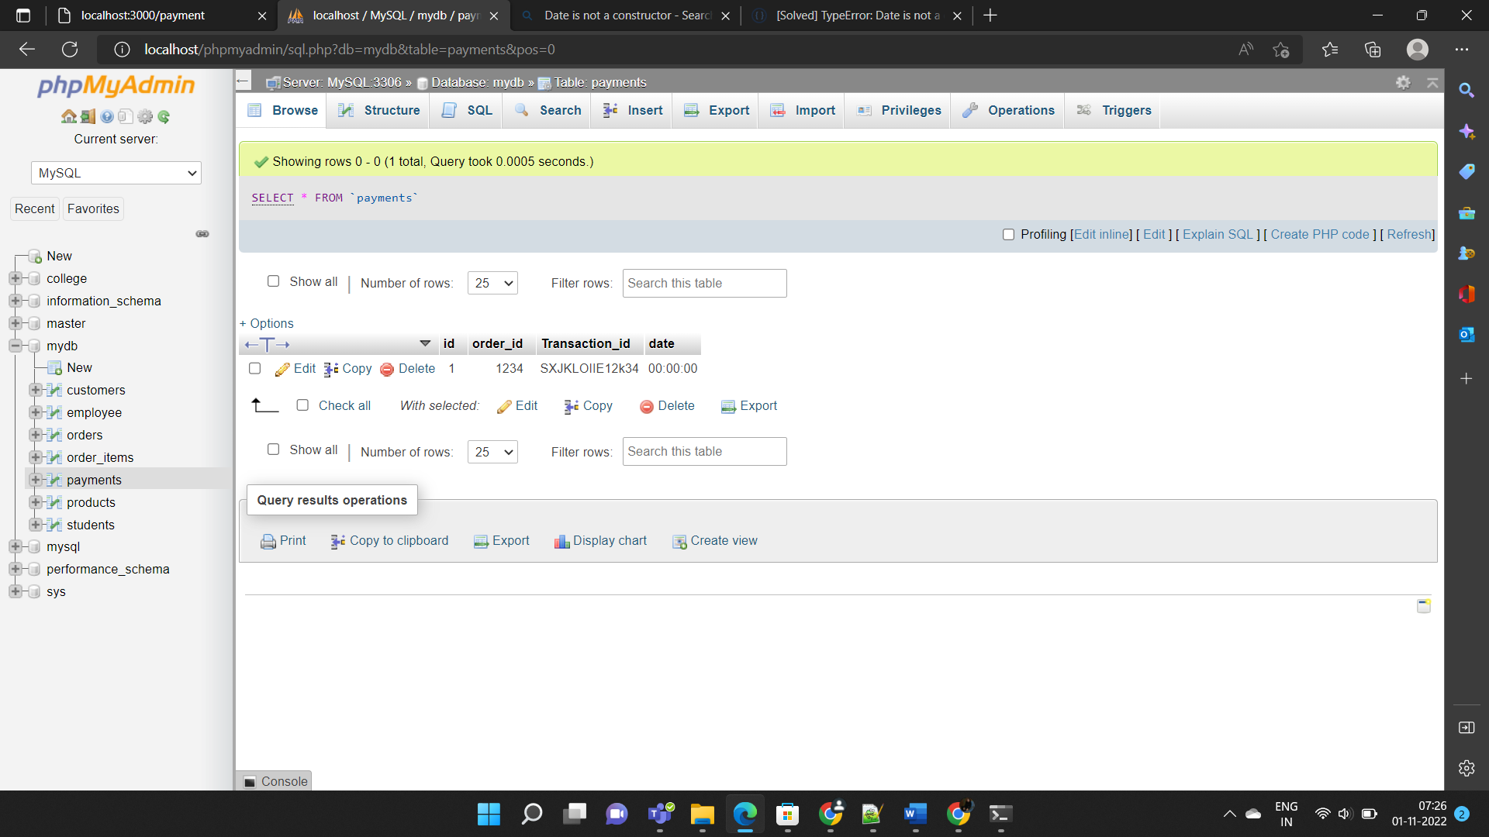

**IMPLEMENTATION CODE**

**SERVER SIDE:**

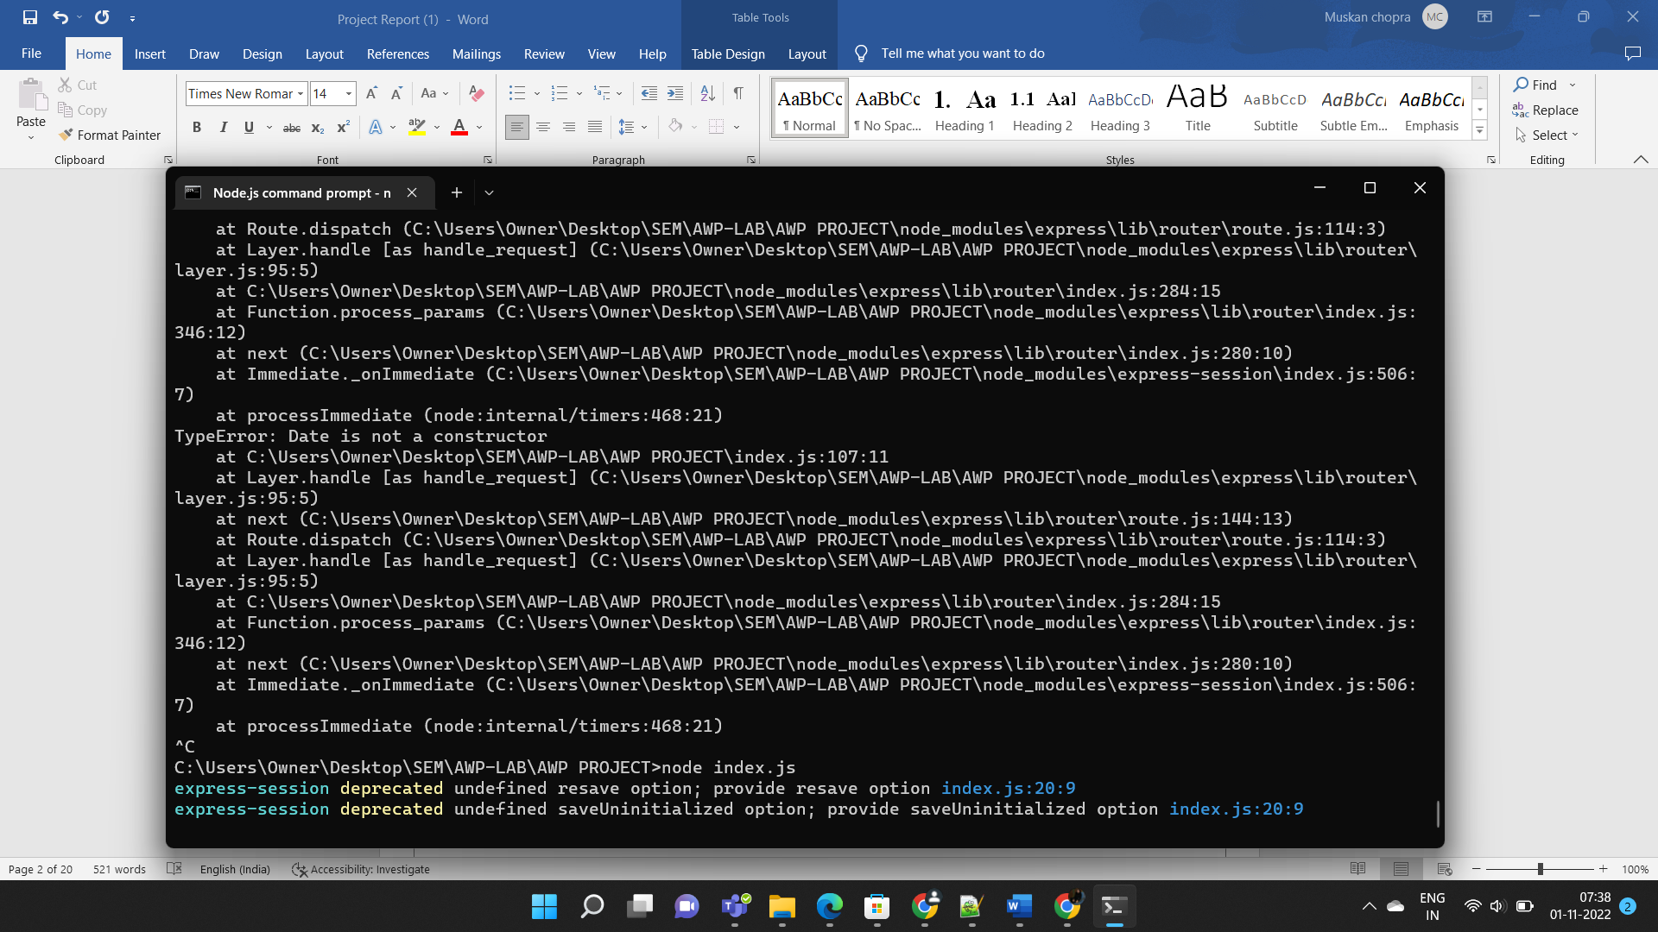

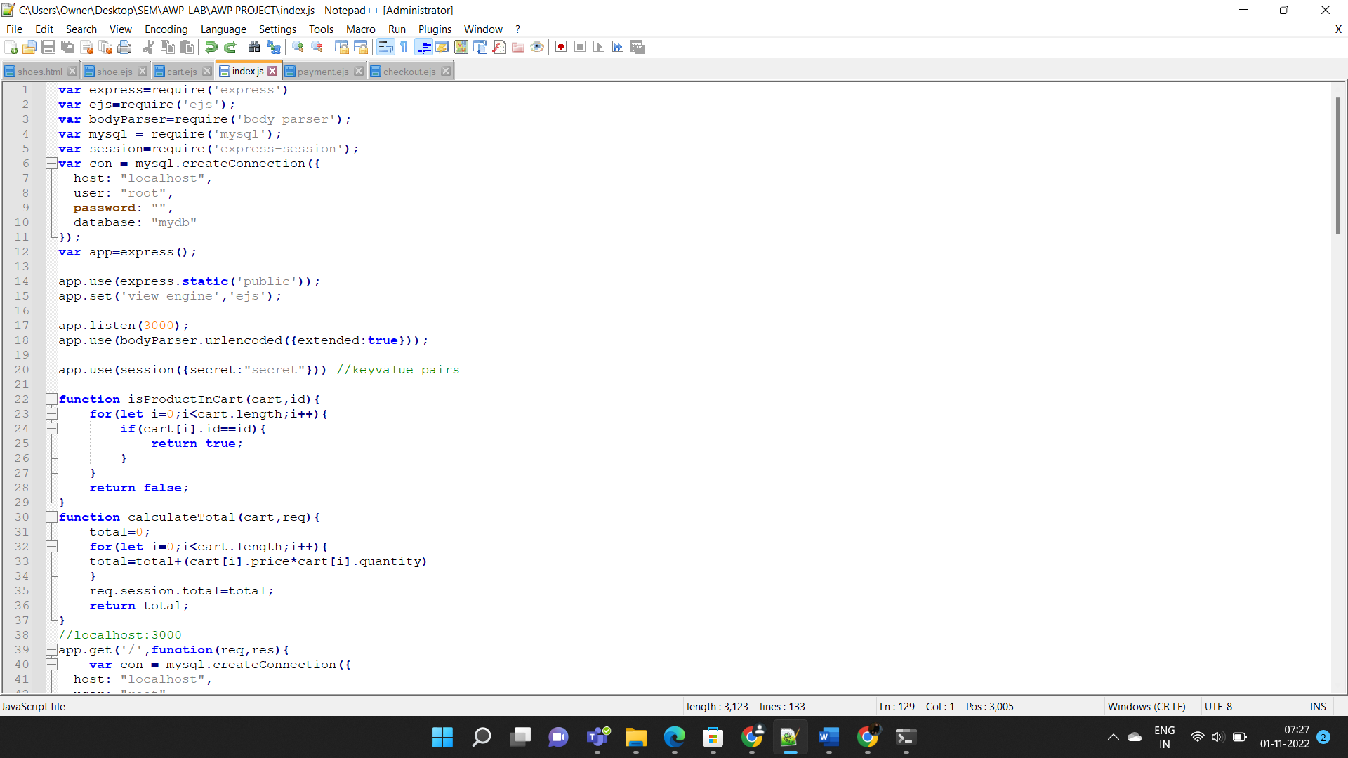

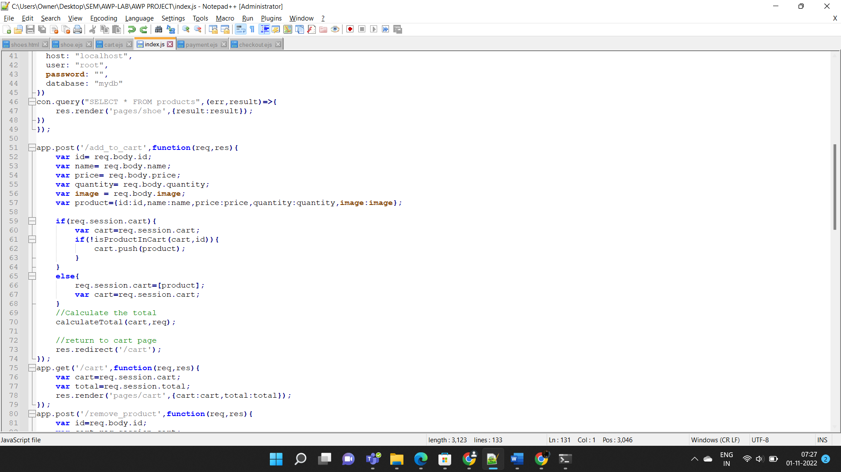

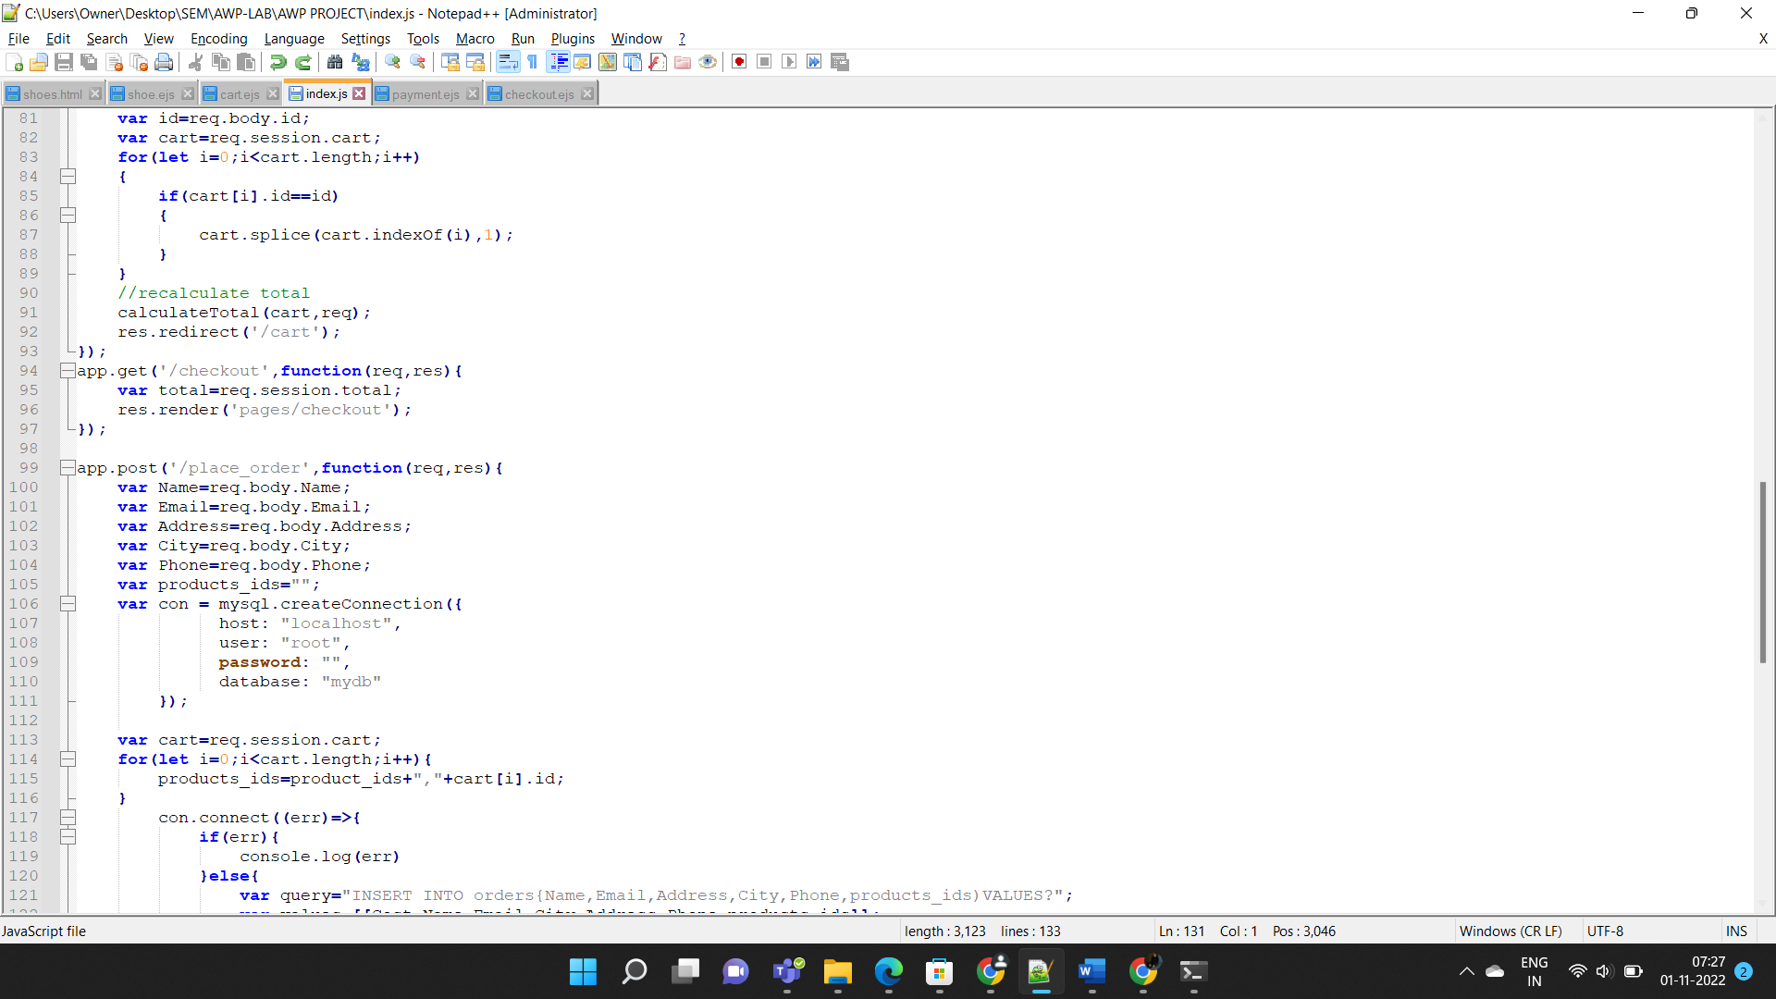

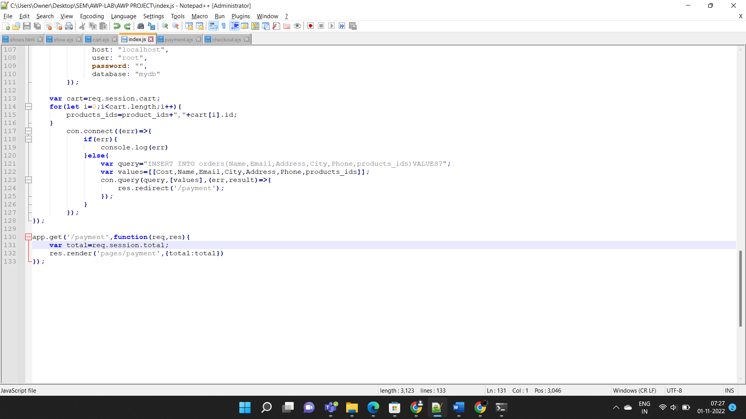

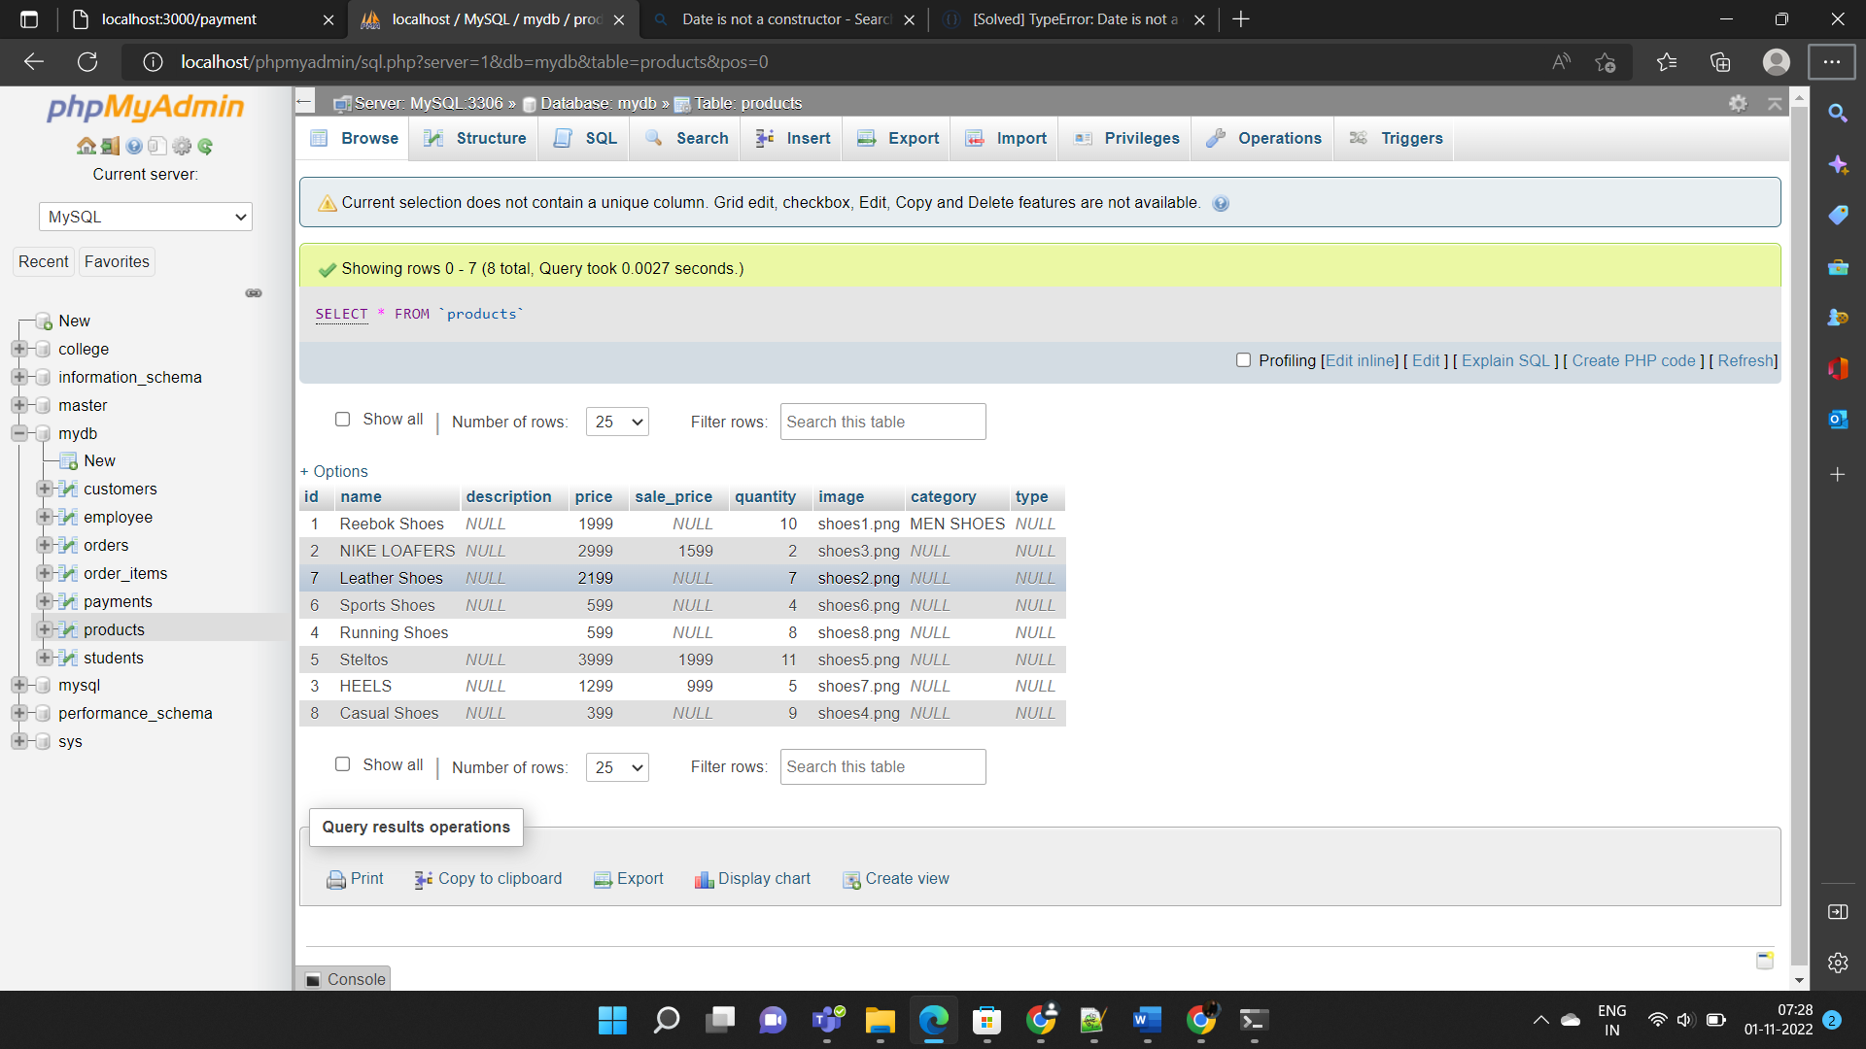

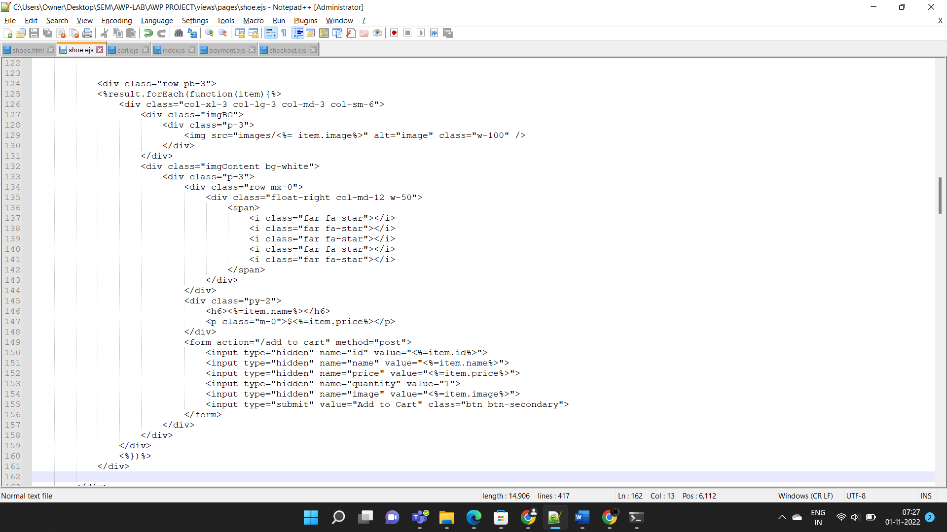

**CLIENT SIDE:**

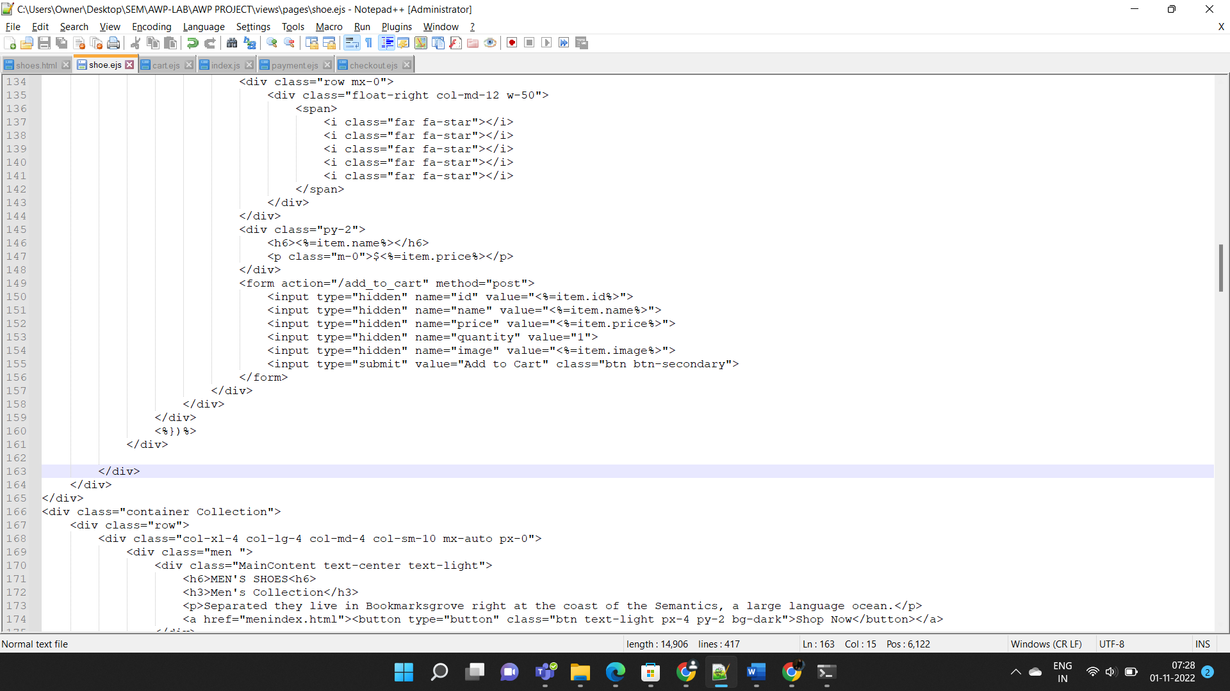

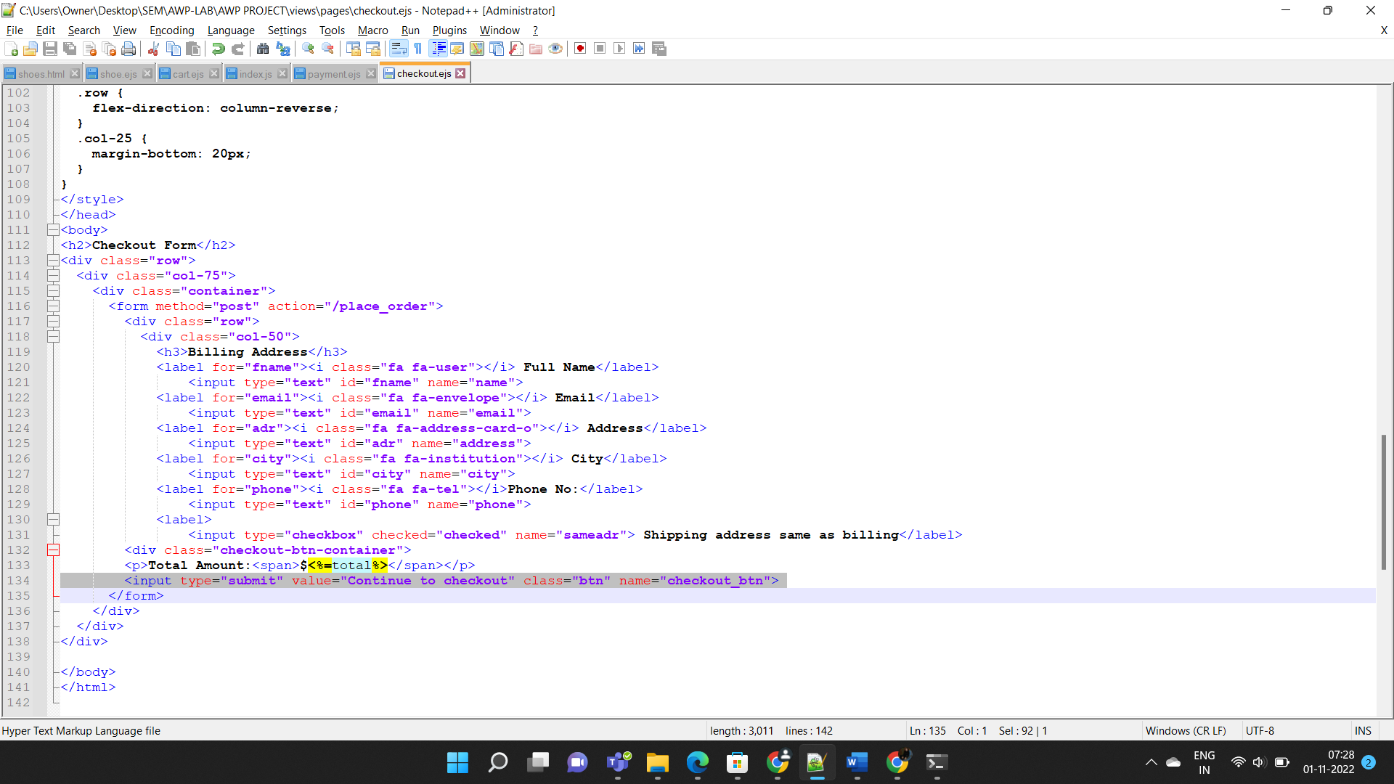

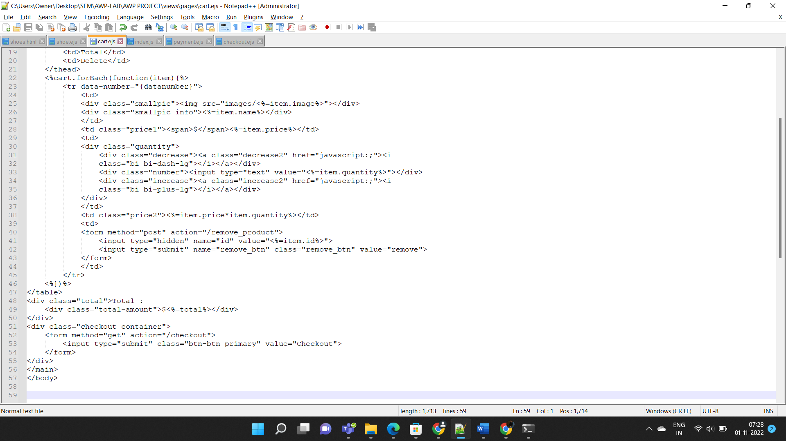

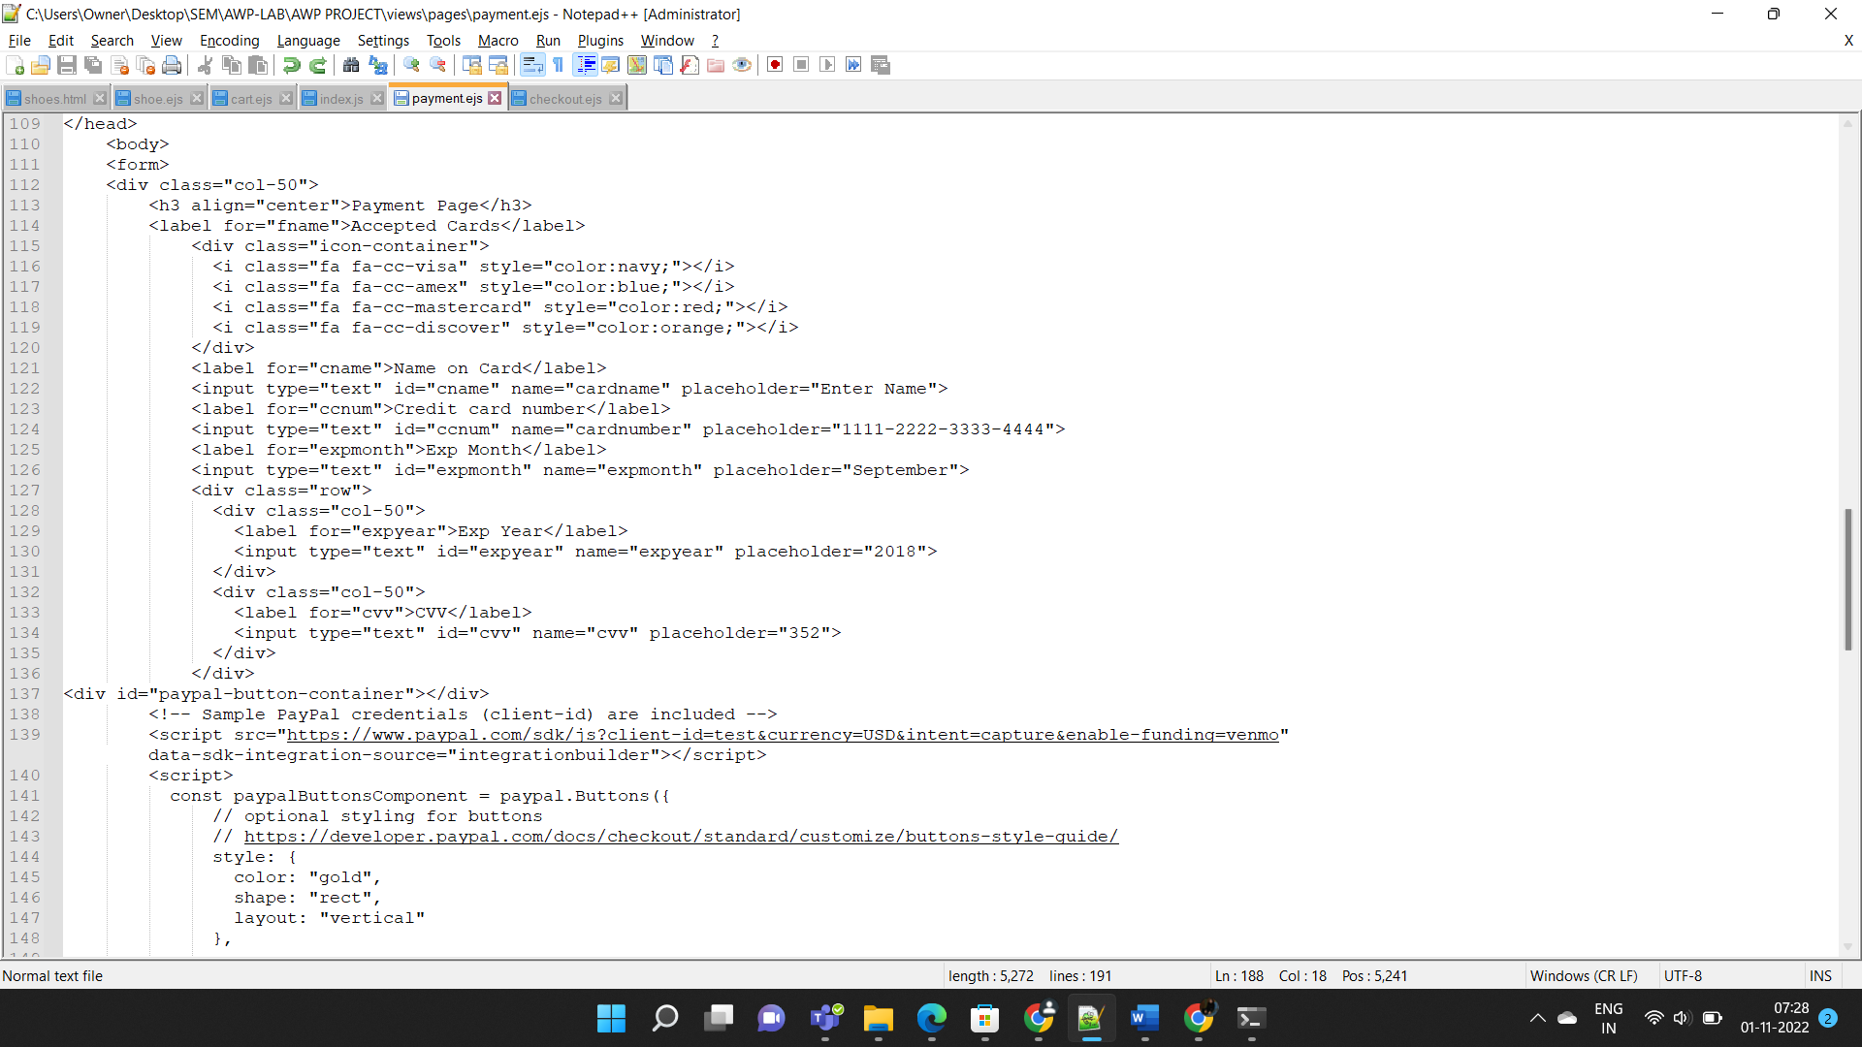

**RESULTS:**

The Minishop Shoe store is being developed using the above technologies and various features have been used to make the website responsive i.e supports all type of devices,mobiles,ipad,laptop,pc etc,thus is efficient and easily accessible.This will allow users to purchase from the comfort of their home without travelling to shops n searching for shoes.

**References:**

1.<https://www.w3schools.com/nodejs/nodejs_mysql.asp>

2. <https://stackoverflow.blog/2021/10/25/node-js-makes-fullstack-programming-easy-with-server-side-javascript/>

3. <https://www.youtube.com/watch?v=W1Kttu53qTg>